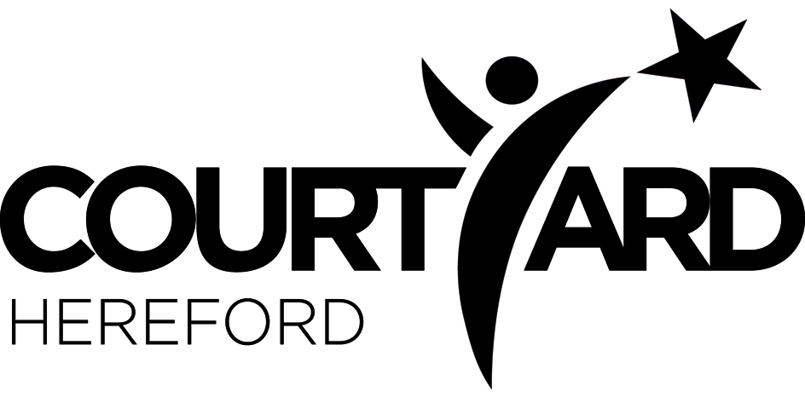

2nd February 2019
Wizard of Oz T-shirts and Hoodies Order form
Please complete the form overleaf and return to your practitioner NO LATER THAN 2nd March 2019
Payment must be made at Box Office, please keep the ticket as you will need this as proof of purchase. The Box Office will stamp your order form when you pay.
Available:
- GREEN t-shirts for the GREEN CAST: £10
- YELLOW t-shirts for the YELLOW CAST: £10
- BLACK AND GOLD Hoodies CHILD: £25
- BLACK AND GOLD Hoodies Adult: £28
- Child t-shirt and hoodie combo deal: £30
- Child t-shirt and adult hoodie combo deal: £33
You can view samples in the Courtyard Foyer and also on line, check out some of our lead year 8 & 9’s modelling them at https://www.courtyard.org.uk/youth-theatre/ and click on NEWS
Name of Youth Theatre member:
Year group:
T-Shirts GREEN |  | Age 3-4 years (£10) | Age 5-6 years (£10) | Age 7-8 years (£10) | Age 9-11 years (£10) | Age 12-13 years (£10) | Age 14-15 years (£10) |  |  |  |  |  | OFFICE USE ONLY Total:
Child Only | Size (√)
 | Quantity
T-Shirts YELLOW |  | Age 3-4 years (£10) | Age 5-6 years (£10) | Age 7-8 years (£10) | Age 9-11 years (£10) | Age 12-13 years (£10) | Age 14-15 years (£10) |  |  |  |  |  | OFFICE USE ONLY Total:
Child Only | Size (√)
 | Quantity
Hoodies BLACK/GOLD: |  | Age 3-4 years (£25) | Age 5-6 years (£25) | Age 7-8 years (£25) | Age 9-11 years (£25) | Age 12-13 years (£25) | Adult Small (£28) | Adult Medium (£28) | Adult Large (£28) | Adult XL (£28) | Adult XXL (£28) |  | OFFICE USE ONLY Total:
 | Size (√)
 | Quantity
 |  |  |  |  |  |  |  |  |  |  |  | ORDER TOTAL:
PAID ON : ( BOX OFFICE DATE STAMP )
Please tick boxes to indicate your choices, if you would like to order more than one please write the amount you would like of each.
Your hoodies will be given out in your Youth Theatre sessions.

