**Activity Two: Roll and Retell**

Use your storyboard of your favourite Roald Dahl book in this activity and with a partner, take it in turns to roll a dice and answer the following questions. If you land on the same number as your partner, how can you answer the question differently?



What happens in the story?

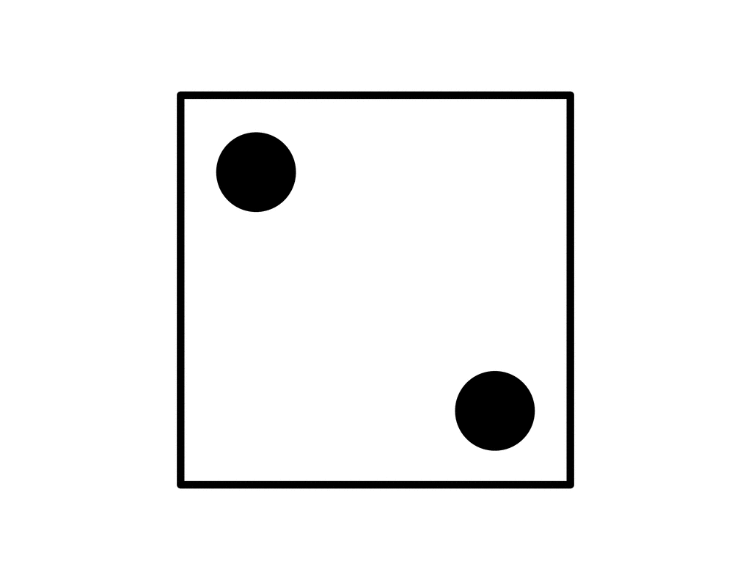

Who are the main characters and how would you describe them?

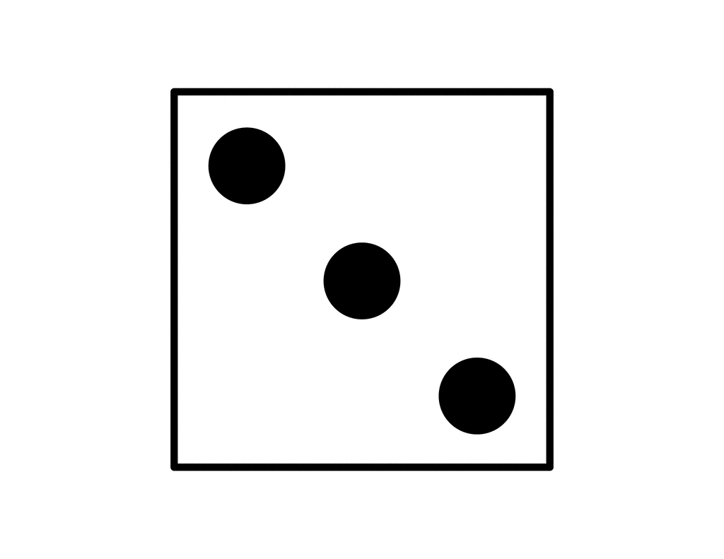

Where does the story take place and can you describe it?



When does the story take place? What clues are there?

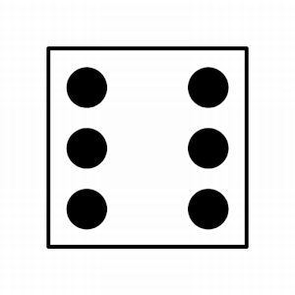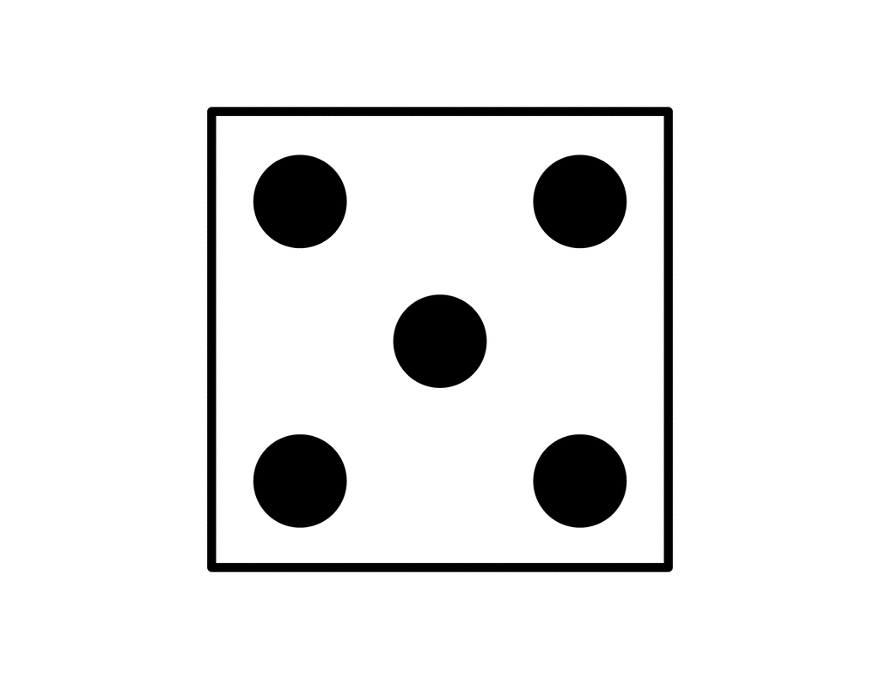

How are these problems solved?

What problems do the characters come across?