**Shakespeare Wordsearch**

*Can you find 15 of Shakespeare’s plays in the wordsearch below?*

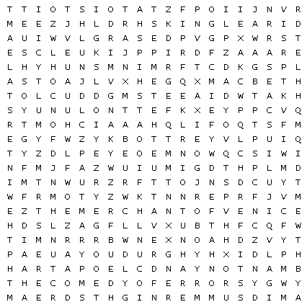

|  |
| --- |
|  |
|  |
|  |
| CY H_log_35c100m35y10k.jpg |
|  |

