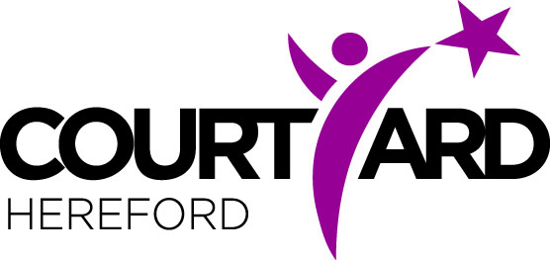

Shakespeare Activity Sheet

*Here are some words that Shakespeare created that don’t get used too much today. Have a look at them and see if you can figure out what they might mean, before looking at the definitions below:*

**Slug-abed**

**Yesternight**

**Tricksy**

**Bibble-babble**

*And here are the words meanings, along with what play they come from:*

Slug-abed (From *Romeo and Juliet*) – Meaning: *Someone who is lazy*

Yesternight (From *Hamlet*) – Meaning: *Last night*

Tricksy (From The *Tempest*) – Meaning: *Playful or cheeky, always playing tricks*

Bibble-babble (From *Twelfth Night*) – Meaning: *Talking nonsense*

*Now, can you write 4 sentences, each using one of the words that we have just learnt? Write them below:*