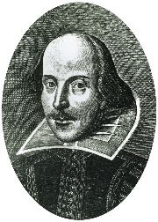
Shakespeare Soliloquys

In today’s session, you have brought to life a famous Shakespeare soliloquy! Can you choose a Shakespeare character and create your own speech?
Top Tip! A soliloquy is a speech spoken by a character who is alone on stage. Think about what your character might share with an audience but not with another character in the play…

……………………………………………………………………………………………………………………………………………………………………………………………………………………………………………………………………………………………………………………………………………………………………………………………………………………………………………………………………………………………………………………………………………………………………………………………………………………………………………………………………………………………………………………………………………………………………………………………………………………………………………………………………………………………………………………………………………………………………………………………………………………………………………………………………………………………………………………………………………………………………………………………………………………………………………………………………………………………………………………………………………………………………………………………………………………………………………………………………………………………………………………………………………………………………………………………………………………………………………………………………………………………………………………………………………………………………………………………………………………………………………………………………………………………………………………………………………………………………………………………………………………………………………………………………………………………

