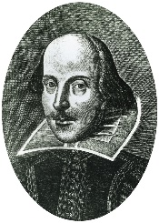
Diary Entry
In today’s session, you have learned different manoeuvres to create an epic stage combat fight! Can you pick a famous Shakespeare character
(eg. Romeo, Hamlet, The Witches) and create a diary entry about your fight?

Draw a picture of your battle here!

………………………………………………………………………………………………………………………………………………………………………………………………………………………………………………………………………………………………………………………………………………………………………………………………………………………………………………………………………………………………………………………………………………………………………………………………………………………………………………………………………………………………..………………………………………………………………………………………………………………………………………………………………………………………………………………………………………………………………………………………………………………………………………………………………………………………………………………………………………………………………………………………………………………………………………………………………………………………………………………………………………………………………………………………………………………………………………………………………………………………………………………………………………………………………………………………………………………………………………………………………………………………………………………………………………………………………………………………………………………………………………………………………

