Seat Sponsorship 2021-22
By sponsoring a seat in our Main House or Studio you can make a very visible show of support for this fantastic charity.
Sponsorships are acknowledged with a plaque personalised with your chosen inscription on your preferred seat, lasting for one or two years.

Packages per year
Studio Main House
£200 each £300 each
£300 for 2 years £500 for 2 years
Seat sponsorship fees are donations so if you can Gift Aid that donation, please let us know.

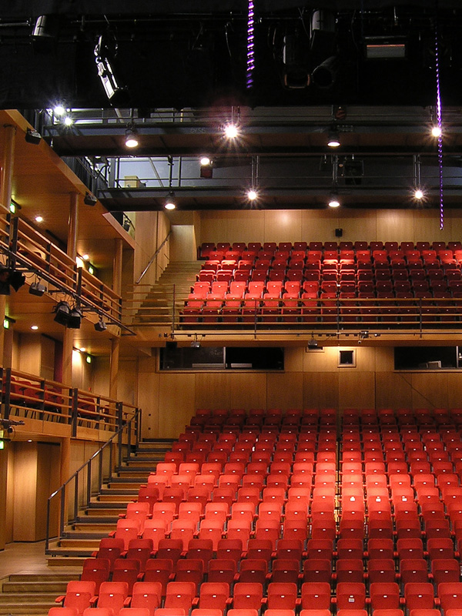

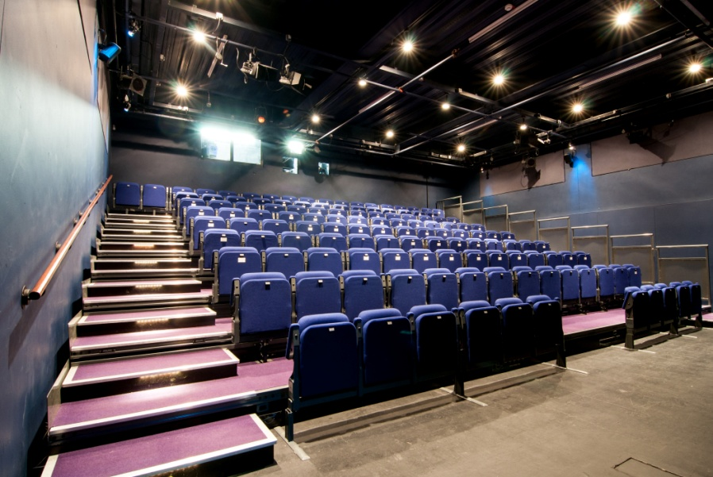

If you would like to sponsor a seat, please fill in the form and return it to

Clare Wichbold MBE, Fundraising Manager, The Courtyard, Edgar Street, Hereford, HR4 9JR

or clare.wichbold@courtyard.org.uk

Seat Sponsorship Application

Full Name: _______________________________________________________________________
Address:__________________________________________________________________________
__________________________________________________________________________________
Telephone: _______________________________________________________________________
I wish to sponsor _____ (number of) seats in the Main House (£300 each/£500 a pair)
I wish to sponsor _____ (number of) seats in the Studio (£200 each/£300 a pair)

My plaque dedication (maximum of characters 50 including spaces between words)
e.g. The Jones Family, In Memory of Jack Smith:
__________________________________________________________________________________
__________________________________________________________________________________
I wish to donate an additional £_______ towards The Courtyard.

If you are a UK tax payer & can gift aid this/any other donations, please ask for
a Gift Aid form at Box Office or ask them to check if they’ve got a completed form
already if you are unsure.
To pay by cheque: Please make the cheque payable to The Courtyard Trust.
To pay by credit/debit card: Please call box office on 01432 340555.
To pay by standing order, please tick here
Ask for a standing order form from Box Office or download the form which should be completed and accompany this booking form.

Main House: £30 a month x 10 months or £50 a month x 10 months (for two seats)
Studio: £20 a month x10 months or £30 a month x 10 months (for two seats)

Please hand in this form to Box Office or post to: Clare Wichbold MBE, Fundraising Manager,
The Courtyard, Edgar Street, Hereford HR4 9JR. On receipt of the completed application form and standing order form (if applicable), we will contact you to confirm your booking and dedication.

For further information on supporting The Courtyard, please call the Fundraising team
on 01432 346505 or email clare.wichbold@courtyard.org.uk

Thank you for your support

