Adopt a seat 2022-2023
By adopting a seat in our Main House or Studio you can make a very visible show of support for our fantastic charity.
Adoptions are acknowledged with a plaque personalised with your chosen inscription on your preferred seat for three or five years depending on the package you choose. For an extra £25 per seat you can have a silver plaque to celebrate our 25th anniversary in 2023.

Packages per year
Studio Main House
£200 each £300 each
£300 for two years £500 for two years
Seat adoption fees are donations so if you can Gift Aid your donation, please let us know.

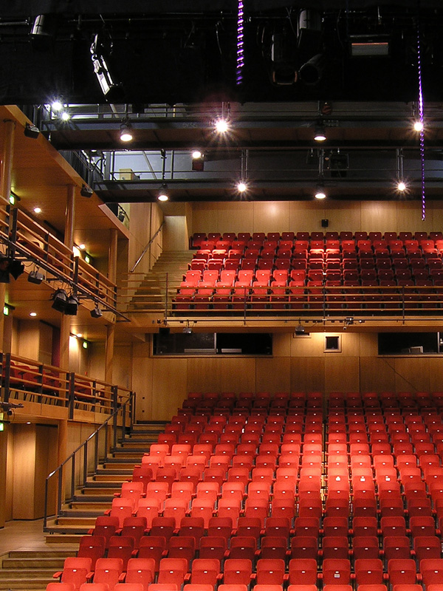

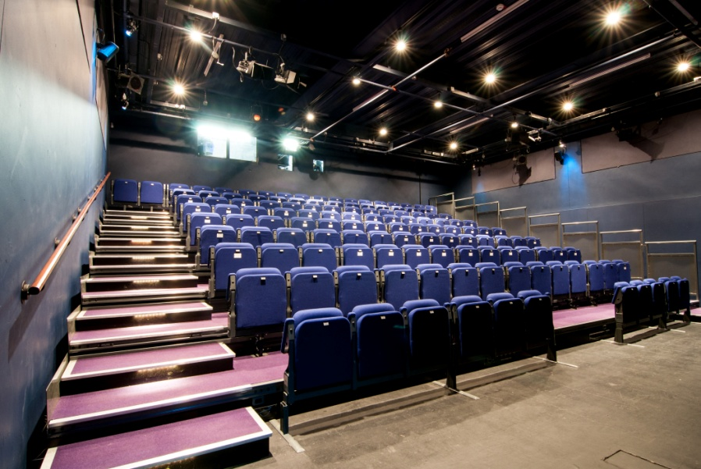

If you would like to adopt a seat, please fill in the form and return it to:

Clare Wichbold MBE, Fundraising Manager, The Courtyard, Edgar Street, Hereford, HR4 9JR or email clare.wichbold@courtyard.org.uk

Adopt a seat application

Full Name: _______________________________________________________________________
Address:__________________________________________________________________________
__________________________________________________________________________________
Telephone: _______________________________________________________________________
I wish to adopt _____ (number of) seats in the Main House (£300 each/£500 a pair)
I wish to adopt _____ (number of) seats in the Studio (£200 each/£300 a pair)

My plaque dedication (maximum of characters 50 including spaces between words)
e.g. The Jones Family, In Memory of Jack Smith:
__________________________________________________________________________________
__________________________________________________________________________________
I wish to have _____ silver plaque(s) at an additional cost of £25 per seat

If you are a UK tax payer & can gift aid this or any other donations, please ask for
a Gift Aid form at Box Office or ask them to check if they’ve got a completed form
already if you are unsure.
To pay by cheque: Please make the cheque payable to The Courtyard Trust.
To pay by credit/debit card: Please call box office on 01432 340555.
To pay by standing order, please tick here

Ask for a standing order form from Box Office or download the form which should be completed and accompany this booking form.

Main House: £30 a month x 10 months or £50 a month x 10 months (for two seats)
Studio: £20 a month x10 months or £30 a month x 10 months (for two seats)

Please hand in this form to Box Office or post to: Clare Wichbold MBE, Fundraising Manager,
The Courtyard, Edgar Street, Hereford HR4 9JR. On receipt of the completed application form and standing order form (if applicable), we will contact you to confirm your booking and dedication.

For further information on supporting The Courtyard, please call the Fundraising Manager
on 01432 346505 or email clare.wichbold@courtyard.org.uk

Thank you for your support!

